**AIDM7400**

**Group Project Report**

**Semester 2**

**Group Members:**

                                                            Qiu Siying 23467274

                                                            Jiang Nanhezi 23473452

                                                            Luo Fan 23435968

     Zhu Xiaoyu 23422041

**Popular Drinks Worldwide ——'World Beer Research'**

**INTRODUCTION**

In our daily lives, beer has become a cultural symbol of many societies. From joyful gatherings to solitary moments in the evening, it has won the hearts of countless people with its diverse styles and flavors.

However, when we raise our glasses and drink, how many of us pay attention to the stories hidden under the foam?

**Part1 World beer popularity**

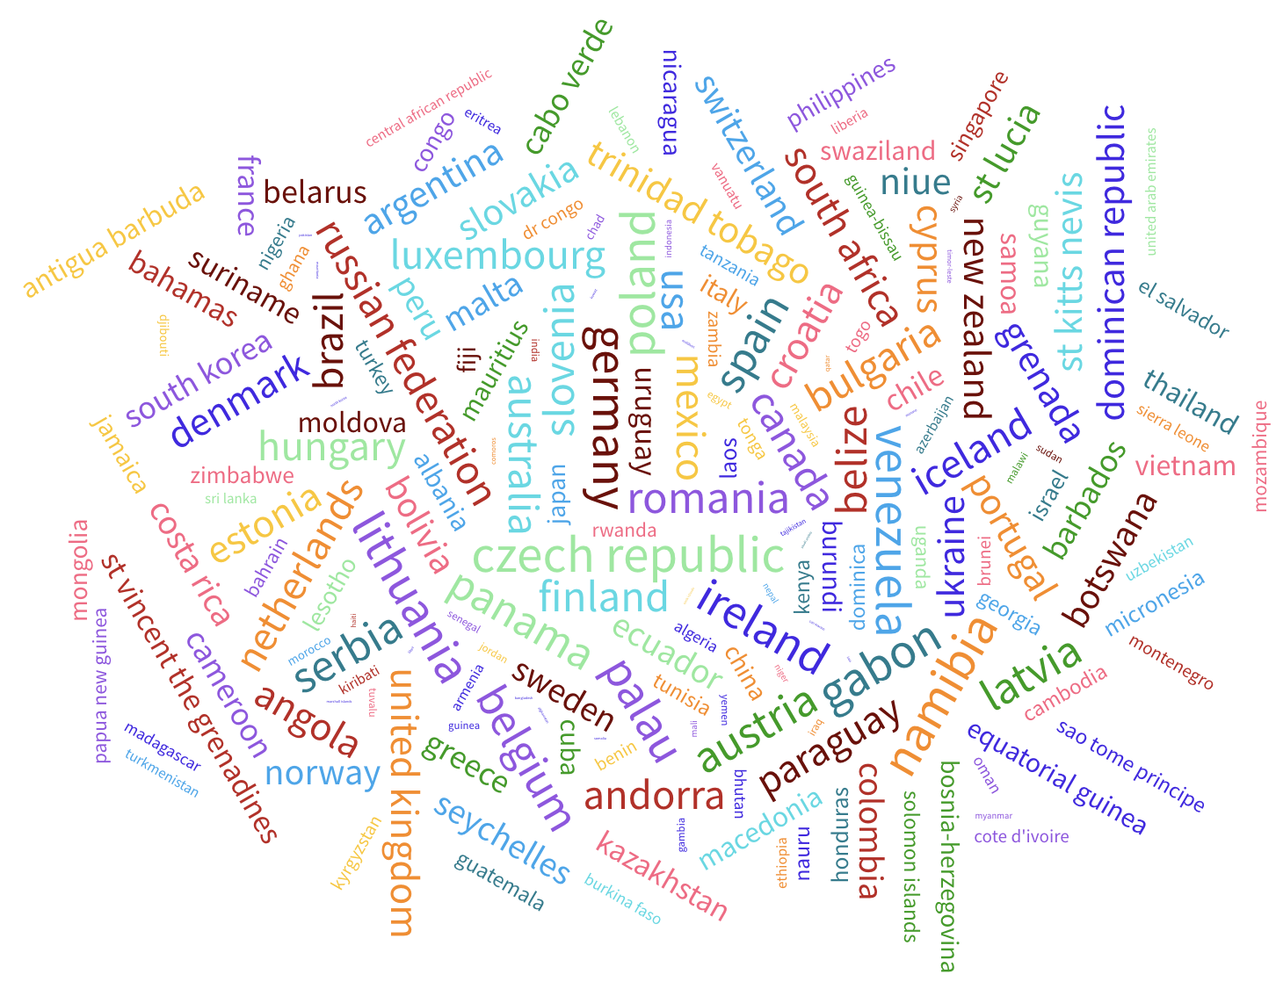

Today, beer has become one of the most popular drinks in the world. Residents in more than 40 countries consume an average of more than 200 cans of beer per year, which means that each resident consumes one bottle of beer a day and a half on average.

The average personal consumption of residents in 'Namibia' is as high as 376 per person, and the average person in the country consumes more than one bottle of beer a day, which shows the popularity of beer in the world.

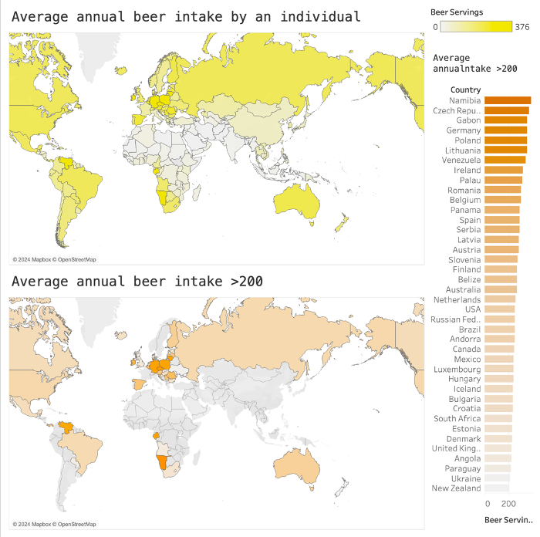

**Countries with Low Alcohol Consumption**

But in addition to these countries, there are also countries where the annual alcohol intake is very low or even zero. This is inseparable from the religious culture, legal policies in these areas.

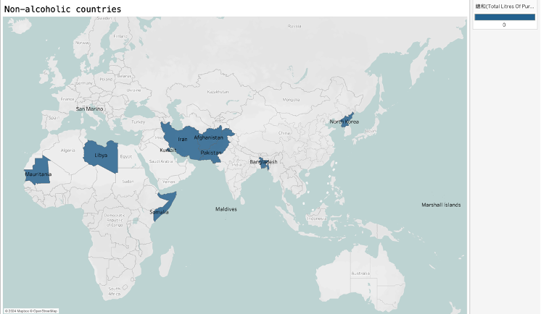

The first situation is related to religious beliefs. Some religious cultures explicitly prohibit the consumption of alcohol. For example, Saudi Arabia, Afghanistan and Malaysia are mainly Muslim countries, and alcoholic beverages are also restricted in these countries. Muslims are prohibited from drinking alcohol, but non-Muslims can purchase and drink alcoholic beverages in certain places.

Another situation is due to legal policies. Some national policies do not allow residents to consume alcoholic beverages. For example, Scandinavian countries (Norway, Sweden, Finland, etc.) implement strict alcohol control policies. These countries strictly regulate the sale of alcohol, often only allowing the sale of alcoholic beverages at certain times and locations.This is why annual alcohol intake in these countries is very low or even zero.

**Comparison of the popularity of beer and other alcoholic beverages**

Even so, alcoholic beverages have still become popular and common drinks in the world. The drinks sold in many countries add trace amounts of alcohol. For example, the country Belarus sells the largest number of alcoholic drinks in the world, but in fact, the consumption of pure alcohol in Belarus is much higher. Not as good as the second-ranked Grenada’s 14L.

Beer is the most common alcoholic beverage. Most countries that like alcoholic beverages like beer. Among the top five countries with pure alcohol consumption, three countries also have very high beer consumption.

In addition to beer, there are many types of wine in the world, such as wine brewed from grapes, beer fermented from barley, hops, etc., spirits with higher alcohol concentration (whiskey, vodka, agape, etc.) liqueur, brandy, etc.) and sparkling wine 'Champagne' which is fermented in a specific way.

However, the types of alcohol preferred in each region are different. For example, the average annual pure alcohol intake of Russians has reached 11.5L, while the per capita sales of alcoholic beverages (including the sales of beer and red wine) are only at a medium level, which shows that Russians prefer spirits.

In contrast, beer is more popular in European regions (especially Poland, Germany, etc.) and North and South America.

Red wine is only popular in continental Europe and southern South America.

There are also countries that like both red wine and beer, such as Australia.

**Part2 Beer composition analysis**

From this data visualization, we can see that the alcohol content of beer produced by countries around the world varies, reflecting their unique production preferences and drinking culture. The high-concentration beer produced in Sri Lanka (8.4%) also has certain reasons: according to Economy Next (2017), before 2015, Sri Lanka's alcohol tax gave an advantage to high-concentration beer, with a tax per alcohol content being more favourable for soft liquor, leading to the prosperity of Sri Lanka's high alcohol beer. Therefore, brewers here tend to brew high-concentration beer.

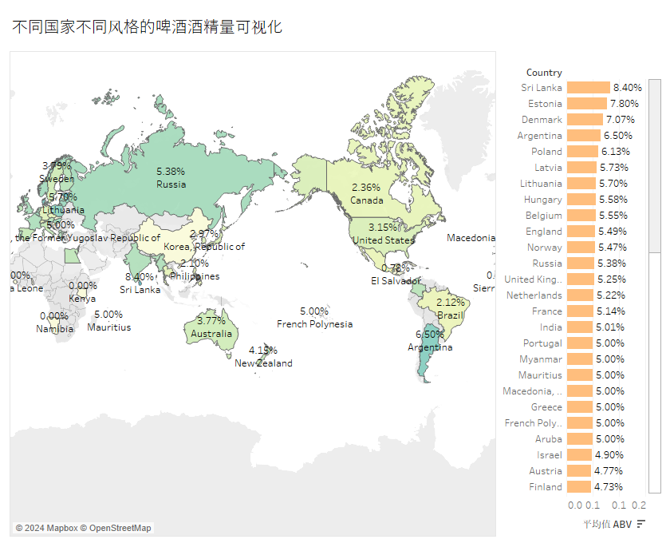

At the same time, beer produced in different countries also has their own unique styles. In the tree graph, we can see that the Belgian Style Quadrupel has the highest alcohol concentration, reaching 11.44%, while others such as Strong Ale and American Style Imperial Stout also show higher alcohol content.

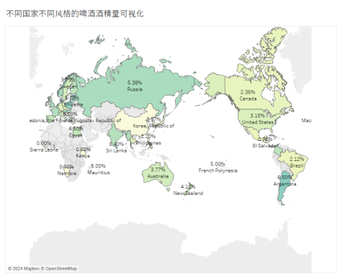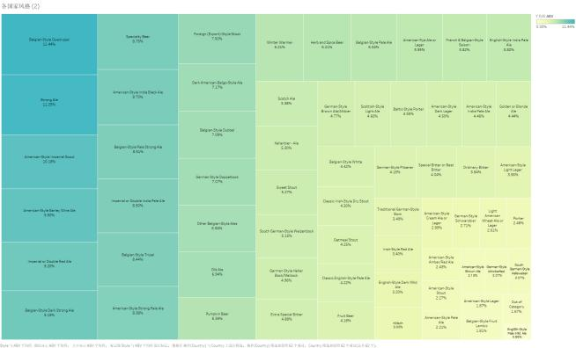

Subsequently, we analyzed the top ten styles of beer and their corresponding alcohol concentrations. From these charts, we can not only see which beer styles have the highest alcohol content but also observe the fluctuations in alcohol concentration between each style. High-concentration beers such as English Barleywine, Quadruple, and American Barleywine are the most popular among beer enthusiasts. However, from the box plot, although the average alcohol content of Quadruple and English Barleywine wine is both above 10%, their box plots reveal a wider alcohol concentration distribution, indicating that even for the same style of beer, different brewers may have different brewing methods that lead to different alcohol concentrations.

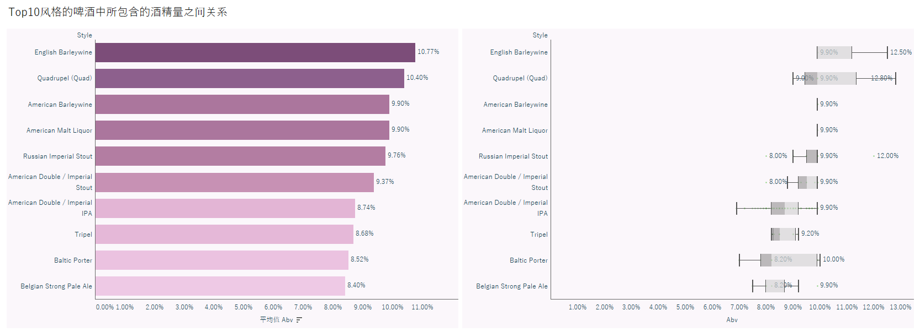

We can see from this scatter plot that the alcohol content of most beer samples is concentrated between 5% and 10%, while IBU is widely distributed between 20 and 100. This indicates that there is currently a variety of beers on the market, such as ranging from mild Lager to strong Russian Imperial Stouts.

Although it is generally believed that high-alcohol beer usually brings a stronger bitterness to people, but from this picture, it can be seen that the relationship between these two is not static. The scatter plot shows that in certain regions with higher ABV, the range of IBU variation is very wide, indicating that even beer with similar alcohol content has significantly different bitterness intensity. Meanwhile, some beers with higher alcohol content can also exhibit lower IBU, indicating that brewers have adopted different formulas and brewing methods in pursuit of beer taste balance to make the beer taste more diverse.

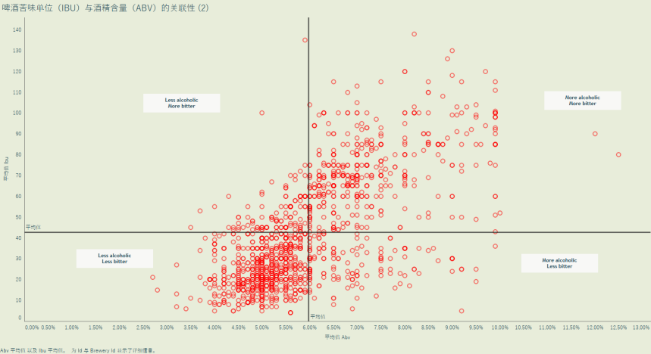

**Part3 Beer production and market**

In our research, we not only care about the beer population but also pay attention to beer production. After analyzing the origins of beer in the world, we mainly take the example of China to illustrate beer production and market. We collect the dataset about beer information that includes the origin and score of it.

**Which origins performed best?**

Based on the data, we want to find the relationship between beer origin and score and produce a tree map that visualizes the scores in different origins, and origins with high scores can be easily found. From the chart, we know that the origins with the highest average score are in Belgium, Namur and West-VanDoren; they get 20, presenting the darkest color on the graph. Besides, Luxembourg of Belgium and Sweden get second place on the chart, representing both at 19. Overall, origins located in Belgium receive higher average scores, with three of the top four highest-scoring origins being in Belgium, so we can infer that the beers produced in Belgium tend to be more popular.

Combined the origins and beer style, it can lead the figure below, showing the beer styles of high score origins. In Minnesota of US, it produced several styles beers like Oatmeal stout and Robust Poter,etc. And there are also some origins that concentrated on certain single beer style like Namur of Belgium and California in US.

**Beer production and Market situation in China**

Next, we will focus on the beer production and market situation in China. The bar graph represents the annual beer production, and the line graph represents the year-on-year growth. The trends of the two are basically the same. From 2018 to 2020, beer production experienced an increase first and then a sharp decline. From 2019 to 2020, beer production dropped from 37.653 million liters to 34.111 million liters, and the year-on-year growth in 2020 was -7%. Until 2021, the beer production rebound. From 2021 to 2023, beer production will show a downward trend, but the decline will be much smaller than the previous two years.

Combining the corporate data of China's alcoholic beverage industry and beer production data, I made the following chart, using bar charts and heat maps to show the relationship between the two from 2018 to 2023. From the chart, we can know that the change trend in the number of companies in China's alcoholic beverage industry is basically the same as sales volume. It also experienced a sharp decline from 2019 to 2020. From 2019 to 2020, the number of companies decreased from 6,083 to 5,658. Since 2020, there has been a rebound, but the level of recovery is still not as good as in 2019 and 2018.

Overall, China's beer market took a hit in 2020, but gradually recovered in the next three years.

**Part4 Beer and Healthy Life**

**The more you drink ≠ the lower your life expectancy.**

Researchers believe that alcohol can cause damage to the pancreas and heart function, increase the risk of high blood pressure, arrhythmia, and pancreatitis, and affect the functions of the liver and immune system. However, drinking alcohol does not directly have a risk of shortening lifespan.

The visualization above clearly shows the distribution relationship between per capita alcohol consumption and life expectancy across countries. We found relatively high drinking levels in the Russian Federation (11.5 L), France (11.8 L), and Australia (10.4 L). However, we found that the average life expectancy in these countries with higher alcohol consumption was around 70 years, which did not lead to lower life expectancy. On the contrary, some countries in Africa, such as Libya, Zambia, Angola, etc., consume less than 5 liters of alcohol per capita, but their life expectancy is very low (less than 50 years old). Therefore, per capita alcohol consumption and life expectancy may be affected by other factors，such as a country’s economic development level, medical facilities, eating habits, social culture, etc.

Although the above data can confirm that drinking alcohol is not a direct factor in shortening the life span. However, it is worth noting that long-term excessive drinking is likely to cause harm to our bodies. Therefore, if you want to drink alcohol, please know the impact of alcohol on the body in advance.

**Tips for safe drinking:**

If you must drink alcohol, please do so in moderation. No more than one serving a day for women and no more than two servings a day for men, equivalent to 12 ounces of beer, 5 ounces of wine, or 1.5 ounces of spirits (such as rum, whiskey, gin, etc.)

**So how much is "an alcoholic drink"?**

To better help people understand the standard portion sizes of different beverages, the following pie chart shows the portion sizes (in ounces) of common types of alcoholic beverages in life. We can find that ordinary beer, light beer, and red wine contain higher alcohol. It's 12 ounces. Whiskey and Manhattan cocktails contain less alcohol (2 ounces).

How many calories does your favorite drink have?

Contemporary young people are pursuing a perfect and slim figure. Therefore, calories are also a factor that people attach great importance to when choosing alcoholic beverages. Through the visualization of the bar chart below, we find that sherry and brandy have relatively low-calorie content, 74 and 75 calories respectively. In addition, in recent years, light beer has become the mainstream of the domestic beer market. All kinds of beer are becoming more and more "light". Extremely light beer with an alcohol content of 2.3 to 2.5% even occupies the main market share of beer.

**SUMMARY**

We analyzed and visualized some issues worthy of attention through the four dimensions of beer sales, flavor, market and health. In summary, this comprehensive analysis of the beer industry not only reveals its complexity as a cultural phenomenon but also provides a valuable perspective on market insights, while also highlighting the importance of enjoying beer. There are health issues to pay attention to.

|  |  |  |  |  |
| --- | --- | --- | --- | --- |
|  | Part 1 | Part 2 | Part 3 | Part 4 |
| Qiu Siying  23467274 | ☑️ |  |  |  |
| Jiang Nanhezi 23473452 |  | ☑️ |  |  |
| Luo Fan  23435968 |  |  | ☑️ |  |
| ZhuXiaoyu 23422041 |  |  |  | ☑️ |

**REFERENCE**

1.EconomyNext. (2017, Sept 6). Sri Lanka to review alcohol taxes; cut moonshine.

Retrieved from：<https://economynext.com/sri-lanka-to-review-alcohol-taxes-cut-moonshine-8282/>

2.Shantanu Roy. (2010). Alcohol Consumption around the World. Kaggle Research, [Online]. Available:https://www.kaggle.com/datasets/codebreaker619/alcohol-comsumption-around-the-world/data

3. https://www.kaggle.com/datasets/jordansamek/world-of-beers

4. https://s.askci.com/data/industry/a02090a/